THE CHINESE BODY IN Cross-Cultural Perspective:
MEDICINE, FOOD, AND FOOTBINDING

AP/HIST 1075 6.0A
F/W 2015/2016

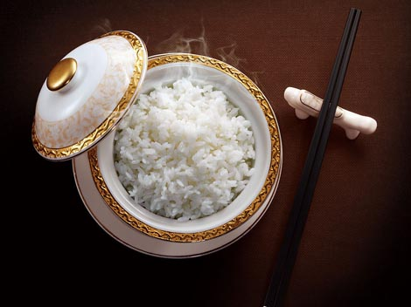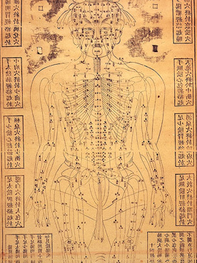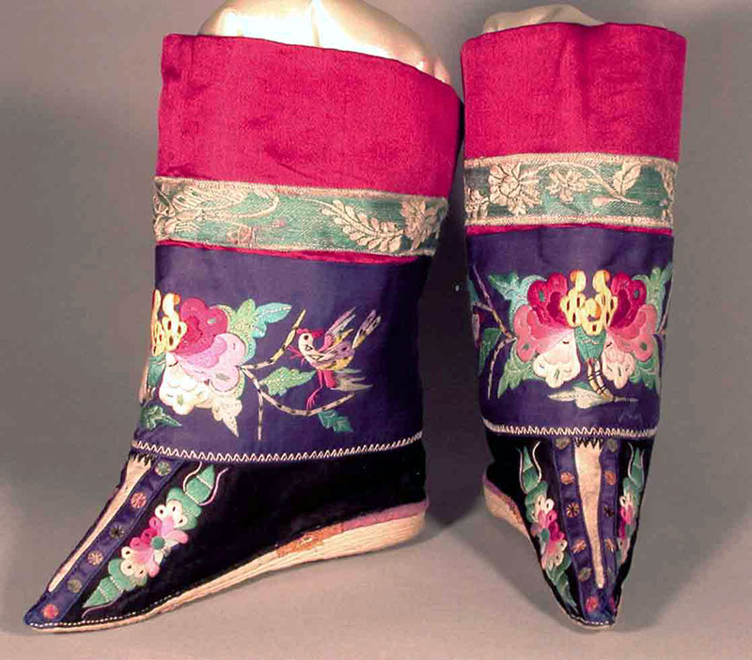

Professor Joan Judge judge@yorku.ca

Office hours: Monday 9:25-10:25 or by appointment
2122 Vari Hall

Lecture: M 10:30-12:30 Vari Hall 2009
Tutorial: M 12:30-14:30 Vari Hall 1158

COURSE DESCRIPTION
This course uses the Chinese body as an entry point into the richness and complexity of daily life as it was lived and experienced in Chinese history. It focuses on two preeminent concerns in Chinese civilization—health and food—and on one of the most mysterious, widely condemned, and little understood Chinese bodily practices—footbinding.
The course is divided into three sections:
HEALING THE CHINESE BODY
NOURISHING THE CHINESE BODY
FOOTBINDING AND THE CHINESE BODY
We will explore these themes through readings, images, film, and literature. Throughout these explorations we will continue to revisit the following overriding questions: How does an examination of everyday bodily experience deepen our understanding of Chinese history and highlight the particularities of Chinese history in comparative perspective? How do Chinese and Western notions of the body differ and what do these differences signal about broader cultural differences?

COURSE MATERIALS
We will use three kinds of materials in class:
-books that you are encouraged to purchase and which you can also borrow from the library’s Reserve desk
-electronic resources which will be posted on our class moodle site
-electronic resources you can access through your York library account

BOOKS
The main course textbook:
Patricia Buckley Ebrey. The Cambridge Illustrated History of China. Cambridge University Press; 2nd edition, 2010.

Our main textbook for the section on food:
E. N. Anderson. The Food of China.ale University Press, 1990.

A novel we will read in the third part of the course on footbinding:
Feng Jicai, The Three-Inch Golden Lotus: A Novel on Foot Binding. University of Hawaii Press: 1994.

ELECTRONIC RESOURCES
-marked in the syllabus as available either on our Moodle site or through electronic resource collections such as JSTOR, Project Muse

ASSIGNMENTS:
Participation: 20%
1. attend class
2. in the lecture: raise informed questions about or give informed comments on some aspect of the reading under discussion
3. in the tutorial: actively engage in discussions of the readings and the issues they raise
Small assignments: 10%
1. Monday September 28: assignment on using electronic resources and our moodle site
2. Monday January 11: map exercise
Exams: 30%
Two MIDTERM EXAMS
Midterm exams will be on material covered in the unit immediately preceding the exam. The second exam will not be cumulative.
The exam format will be identifications and short answers.
Monday October 26
Monday February 22
Short essay: 15%
Monday December 14: Paper on HEALING THE CHINESE BODY, 4-6 pages (1000-1750 words).
5 potential topics will be handed out 2 weeks in advance (November 23) and you will work on these in groups in the tutorial. Two of these five topics will be on the assignment handed out the last day of class, you will write on one of the two.
Final essay: 25%
Monday April 11: Paper on THE CHINESE BODY IN HISTORICAL AND CROSS-CULTURAL PERSPECTIVE, 8-12 pages (2000-3500) words
5 potential topics will be handed out 2 weeks in advance and you will work in these in groups in the tutorial. Two of these five topics will be on the assignment handed out the last day of class, you will write on one of the two.

Students can deposit their written assignments and take-home examinations in the essay drop-off box. This box is located just outside of the main history office, 2140 Vari Hall.

Late submission penalties: Late assignments will be docked 5% each day the assignment is late.
Missed exam policy: Students must provide a medical note if they miss an exam. They will take the exam as soon as they return to class.

ACADEMIC INTEGRITY
Your work in this class must be the product of your own efforts. Plagarism (from books, articles, the internet, fellow students) will not be tolerated and will result in serious consequences from failing the course to expulsion from the university.

GRADING SCHEME:
The grading scheme for the course conforms to the 9-point grading system
used in undergraduate programs at York (e.g., A+=9, A=8, B+=7, C+=5, etc.). Assignments and tests will bear a number grade that corresponds to a letter grade
90 to100= A+
80 to 89 = A
75-79 = B+
70-74=B
65-69 =C+
60-64= C, etc.

IMPORTANT LINKS AND SUPPORT
The History Department is located on the second floor of Vari Hall, 2140. The usual office hours during the academic term are M-F, 8:30am-4:00pm. The department’s phone number for general inquiries is 416 736 5123.

The History Department website: Upcoming events, resources for undergraduate history
students, faculty and staff information, and much more: http://www.yorku.ca/uhistory/
Undergraduate Program in History: links to information on history major career paths, degree programs (what is required for majors, minors, etc.), and decree checklists:
http://www.yorku.ca/uhistory/undergraduatecopy.html

Director of Undergraduate Studies, History Department: Main contact for advising for
history majors or minors and for problems that your professors and/or teaching assistants cannot solve. The Director of Undergraduate Studies holds regular weekly office hours that are drop-in. No appointments are necessary; students will be seen on a first-come, first-served basis. For the current drop-in hours, see http://www.yorku.ca/uhistory/ and look under advising. It is also possible to set up an appointment with the Director if you have a conflict with the drop-in hours. To do so, come to the history department office, 2140 Vari, during regular opening hours to speak with a staff member, or email or call the Undergraduate Program Assistant at patricad@yorku.ca or 416 736 5123.

History Help and Mentorship Centre: Help for any student enrolled in a history course (help with writing assignments, research, exam-taking, etc.) from current, full-time history department graduate students. See http://www.yorku.ca/uhistory/historyhelpandmentorshipcentre/index.html
for more information or email histhelp@yorku.ca for an appointment.

The Writing Centre: One-to-one help with a writing instructor on any writing assignment. You will need to enroll to set up your appointment, though they also offer some drop-in sessions. The enrollment link and further information is found at http://www.yorku.ca/laps/writ/centre/.
Bring a copy of your assignment to your appointment.

York University Libraries: Links to the main catalogue, e-resources, on-line help chat line with librarian, and many other research aids: http://www.library.yorku.ca/web/
SPARK [Student Papers and Academic Research Kit]: On-line tutorial that provides handy tips and tools for understanding and successfully completing university-level assignments. Go to http://www.yorku.ca/spark/

Undergraduate History Student Association: http://www.yorku.ca/uhistory/uhsa.html

Learning Disability Services: http://lds.info.yorku.ca/ and Alt Exams/Test Scheduling
http://altexams.apps01.yorku.ca/ (for students registered with LDS).

York Student Code of Conduct: http://www.yorku.ca/oscr/pdfs/StudentCodeOfConduct.pdf

Academic Integrity Tutorial: http://www.yorku.ca/tutorial/academic_integrity/index.html

History department policy on grade reappraisals, including link to the grade reappraisal
form: http://www.yorku.ca/uhistory/undergraduate/grading_policies.html#appraisals

1. MONDAY SEPTEMBER 14
INTRODUCTION: WHAT TO EXPECT AND HOW TO EXCEL IN HISTORY 1075

HEALING THE CHINESE BODY

2. MONDAY SEPTEMBER 21
LECTURE: YIN AND YANG: FOUNDATIONAL PRINCIPLES IN THE EARLY DYNASTIES
Ebrey: Chapter 1, 2: focus pp. 22-28, 30-35, 42-55

TUTORIAL: ORACLE BONES AND HEXAGRAMS: EARLY APPROACHES TO HEALING
Ebrey: 21
Moodle: “Oracle-bone questions from the Shang Dynasty”

Assignment on using electronic resources and our moodle site due next week.

3. MONDAY SEPTEMBER 28
LECTURE: MEDICAL TEXTS AND MOVING QI: THE HAN DYNASTY
Ebrey: Chapter 3: focus pp. 63-73, 75-82

TUTORIAL: WOMEN AND HEALERS IN EARLY MEDICINE
Moodle: Raphals, Hinrichs

Assignment on using electronic resources and our moodle site due.

4. MONDAY OCTOBER 5
LECTURE: BUDDHISM, DAOISM, AND EXPANDING MEDICAL PRACTICES: THE PERIOD OF DIVISION AND THE TANG DYNASTY
Ebrey: Chapters 4, 5: focus pp. 86, 95-102, 106-07, 117-30

TUTORIAL: THE CHILDBIRTH IMPERATIVE
Ebrey: 114
Moodle: Choo, Wilms, Lee

5. MONDAY OCTOBER 12: NO CLASS, THANKSGIVING

6. MONDAY OCTOBER 19
LECTURE: THE STATE STEPS IN: THE SONG AND JIN DYNASTIES
Ebrey: Chapters 6: focus pp. 136-54, 158-61

TUTORIAL: DAOIST ADEPTS AND THE SPREADING INFLUENCE OF CHINESE MEDICINE
Moodle: Katz, Despeux, Goble

7. MONDAY OCTOBER 26
LECTURE: Review of material to date.

TUTORIAL: MIDTERM EXAM

8. MONDAY NOVEMBER 2
LECTURE: GLOBAL INFLUENCES AND DEEPENING TRADITIONS: THE YUAN AND MING DYNASTIES
Ebrey: Chapters 7, 8: focus pp. 164, 169-79, 190-206, 208-212

TUTORIAL: GLOBAL INTERACTIONS AND THE RISE OF CHILDREN’S MEDICINE
Moodle: Buell, Thompson, Suh, Hsiung, Hammond

9. MONDAY NOVEMBER 9
LECTURE: THE GENTRIFICATION OF MEDICINE: DEVELOPMENTS IN THE QING DYNASTY
Ebrey: Chapters 9: focus pp. 220-34, 246-49

TUTORIAL: WOMEN, PLAGUES, AND IMPERIAL PYSICIANS
Moodle: Bray, Valussi, Benedict, Chang

10. MONDAY NOVEMBER 16
LECTURE: FOREIGN ENCOUNTERS, EUROPEAN MEDICINE, AND THE WEAKENING OF THE QING DYNASTY
Ebrey: Chapter 9: focus pp. 234-46, 249-58

TUTORIAL: VIEWS FROM OUTSIDE AND CHANGES WITHIN
Moodle: Barnes, Hanson

11. MONDAY NOVEMBER 23
LECTURE: PUBLIC HEALTH AND THE BATTLE OVER “CHINESE MEDICINE”: THE REPUBLICAN PERIOD
Ebrey: Chapter 10: focus, 262-91 (option to skip 284)

TUTORIAL: NEW PRACTICES, NEW ILLNESSES, NEW PUBLICITY
Moodle: Heinrich, Shapiro, Rogaski

5 POTENTIAL TOPICS FOR SHORT TAKE HOME PAPER HANDED OUT.

12. MONDAY NOVEMBER 30
LECTURE: MEDICINE IN COMMUNIST CHINA
Ebrey: Chapter 11: focus, pp. 294-302, 305-29 (option to skip 318, 326-27 insert)

TUTORIAL: PROPAGANDA AND NEW INVENTIONS
Moodle: Landsberger, Ownby

13. MONDAY DECEMBER 7
LECTURE: CONTINUITIES AND CHANGES IN CHINESE MEDICINE TODAY
Moodle: Farquhar, DuBois, Jia

TUTORIAL: Work in groups on 5 potential topics for take home paper.

SHORT TAKE HOME PAPER DUE MONDAY DECEMBER 14

WINTER BREAK

NOURISHING THE CHINESE BODY

14. MONDAY JANUARY 4
LECTURE: MAPPING CHINESE FOOD: REGIONAL CUISINES
Anderson, Ch. 10, pp. 194-228

TUTORIAL: RICE CULTURE
Ebrey: pp. 12-13, 73-75, 156-57

Assignment: map exercise due next class.

15. MONDAY JANUARY 11
LECTURE: FOOD AND MEDICINE
Anderson, Ch. 11, “Traditional Medical Values of Food,” pp. 229-43.

TUTORIAL: ELIXIRS AND THE FOOD OF HEALTH
Moodle: “Elixirs and the Food of Health.”

Assignment: map exercise due.

16. MONDAY JANUARY 18
LECTURE: FOOD AND SOCIETY
Anderson, Ch. 12, “Food in Society,” pp. 244-61

TUTORIAL: SOCIAL AND RITUAL FOOD
Ebrey, 318; Moodle, “Cooking.”

17. MONDAY JANUARY 25
LECTURE: FOOD AND TECHNOLOGY
Anderson, Ch. 9, “Some Basic Cooking Strategies,” pp. 182-93

TUTORIAL: VESSELS, UTENSILS, AND FIRE
Ebrey, pp. 217-19; Moodle, “Beijing Men Built a Fire”

18. MONDAY FEBRUARY 1
LECTURE: FOOD IN CHINESE HISTORY: THE LAST DYNASTIES
Anderson, Ch. 6, “Involution: Late Imperial China,” pp. 94-123

TUTORIAL: FOOD IN LITERATURE
Moodle: (Excerpts from Six Records From a Floating Life, Shen Fu)

19. MONDAY FEBRUARY 8
FILM: “Eat, Drink, Man Woman”

TUTORIAL: Review session for MIDTERM EXAM on food.

20. MONDAY FEBRUARY 15: NO CLASS READING WEEK
Start reading ahead: The Three Inch Golden Lotus

21. MONDAY FEBRUARY 22
MIDTERM EXAM

TUTORIAL: Preliminary discussion on footbinding.

FOOTBINDING AND THE CHINESE BODY

22. MONDAY FEBRUARY 29
LECTURE: THE MURKY ORIGINS OF THE PRACTICE OF FOOTBINDING
Moodle: Ebrey: “Women, Marriage, and the Family in Chinese History”

TUTORIAL: MORE DISCUSSION OF ORIGINS
Feng Jicai: “Some Idle Talk Before the Story;” Ch. 4

23. MONDAY MARCH 7
LECTURE: FOOTBINDING AS CLOTHING
Project Muse: Dorothy Ko. “The Body as Attire: The Shifting Meanings of Footbinding in Seventeenth Century China.” Journal of Women’s History 8:4 (Winter 1997), pp. 8-27.

TUTORIAL: FOOTBINDING AS COMPETITION
Feng Jicai: Ch. 5, 6, 7

24. MONDAY MARCH 14
LECTURE: THE ANTI-FOOTBINDING MOVEMENT
Moodle: Drucker, “The Influence of Western Women on the Anti-footbinding Movement”

TUTORIAL: CHINESE WOMEN AND THE ANTI-FOOTBINDING MOVEMENT
Moodle: “The Movement Against Footbinding;” Feng Jicai, Ch. 14, 15, 16

25. MONDAY MARCH 21
LECTURE: THE ANTI-ANTI-FOOTBINDING MOVEMENT
Moodle: Ko, “Introduction,” to Cinderella’s Sisters

TUTORIAL: REACTIONS TO A REVISIONIST HISTORY OF FOOTBINDING
Debate: Can we compare footbinding to high heels? A global comparative perspective.

5 POTENTIAL TOPICS FOR TAKE HOME PAPER HANDED OUT.

26. MONDAY MARCH 28
FILM: Footbinding : Search for the three- inch golden lotus

TUTORIAL: Division into groups to work on 5 POTENTIAL TOPICS FOR TAKE HOME PAPER.

27. MONDAY APRIL 4
Presentation of group work on 5 POTENTIAL TOPICS.

Distribution of final take-home exam.

MONDAY APRIL 11: Take home exam due.

